The Enable pin, nothing happens unless this bit is high. It is connected to Port E, bit 7 on the ES308 Rabbit. This is what allows the keypad and display to share pins. Keypad sets this to low
The select pin. This tells the display whether a command or data line is being sent to it. If data line it prints the character using 8 bit mode (8 wires)

The 4 red wires connect to the keypad for the output bits. The 2 ribbon cables connect to the 8 digital output pins on the ES308 Rabbit board (the extra wires from the ribbon cable are grounded.) bit 0 is on the far right.
Potentiometer is used to adjust the Vee pin, which adjusts brightness of the display

+5 volts, the wires next to it are both grounded. The one to the right is used if reading information from display, if its ground its always in write mode.

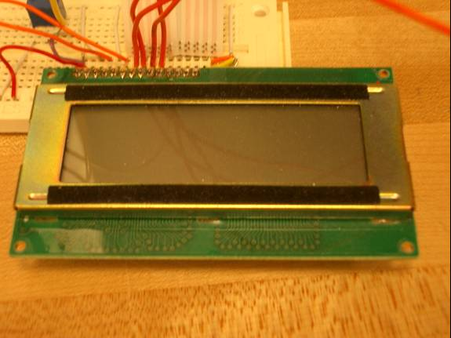
*See the appendix for the block diagram and commands used to control the LCD.

Enclosure 11

